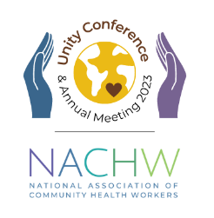
The National Association of Community Health Workers Unity Conference and Annual Meeting:
Community Health Workers: The Workforce We Need for the World We Want
August 3rd-5th, 2023
Thank you for your interest in nominating a CHW for the Hope & Care Awards for the 2023 NACHW Unity Conference! For more information on the awards, please visit: https://nachwunity.org/awards/
If you would like to nominate a Community Health Worker for one of these awards, please fill out the nomination form here: https://form.jotform.com/230044321273038.
Please submit your nomination by Monday, February 20th at 11:59pm EST.
Your name:

Your email:

Your phone number (optional):

Full name of Nominee:

Email Address of Nominee:

Which Hope & Care Award would you like to nominate this person for? (Please only select one)

- Care in Covid Award
- Hope in Healthcare Award
- Equity & Justice Visionary Award
- Change Agent Award
- Lifetime Achievement Award

Why should this CHW receive this award? (250 word maximum)

Optional: Photos, materials, or links about this CHW nominee.

Questions? Please email unityconference@nachw.org
We look forward to reviewing your nomination!

